Skills Workshop #10: Using PowerPoint to Create Your Video

Speaker: Denny Dupps, Technology Resource Person for RET Grant, University of Cincinnati
Date: Monday, July 8, 2019
Time: 10:30 AM – 12 PM
Venue: University of Cincinnati, Baldwin Hall, Room 741

Prepared by:
Akshayaa Venkatakrishnan, Dater High School, Cincinnati, Ohio
RET Participant for Project #1: Bioengineering Therapies for Peripheral Nerve Repair

This session was presented by Denny Dupps, who is the Technology Resource Person for the RET Program on Monday, July 8, 2019 from 10:30 AM -12:00 PM at the University of Cincinnati in Baldwin Hall, room 641. This presentation was given in the second half of the RET program at UC in order to give participants exposure to the use of PowerPoint as a tool for video-making, and how we can capture the research conducted during the summer program in a video to share with other teachers and the judges in the final presentation.

Mr. Dupps currently serves as the Technology Resource person for the CEEMS grant at UC. He earned BS in Industrial Arts Education at Morehead State University and a Masters in Secondary Education from UC, as well as, additional coursework in Information Technology, Computer Science, Digital Video Productions and Robotics. He has been a high school technology teacher at Indian Hill High School for the past 49 years. He served as the President of the Ohio Technology Education Association from 1984-86. He continues to teach part time at Indian Hill High School and is the faculty advisor of the Indian Hill Television Network which produces a weekly news program and many sports and musical programs throughout the district.

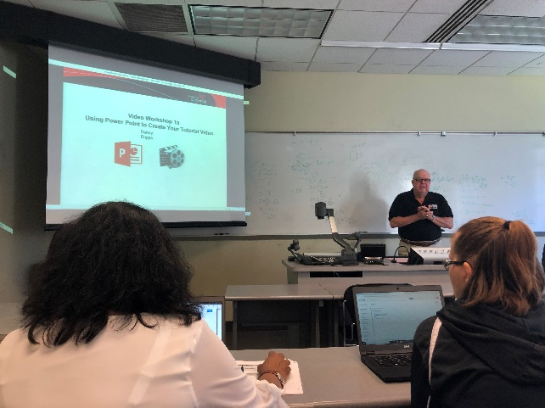

Fig. 1: Denny Dupps presents an overview of using PowerPoint to create videos.

The first topic for the lesson was about how to customize and update the Wiki page which will house our project materials and our video. This is vital in order to make our Wikis not only aesthetically pleasing but to also make it user-friendly and accessible to all users. Participants spent some time updating their Wikis and ensuring that the proper properties are accessible to their RET partner and the program coordinators, including Denny Dupps to give us feedback on the websites. Participants had time to ask questions and troubleshoot access to their websites.

Participants then opened up PowerPoint and Mr. Dupps gave an overview of different tools that can be used in the software. The purpose of using PowerPoint in this project is to create a video; Mr. Dupps asked participants if they had prior experience in using video-making software, and several participants identified different programs they have used in the past. Mr. Dupps identified how the PowerPoint software is similar or different from other video software, and identified the tools in PowerPoint that make it effective for creating videos with audio. He gave participants an overview of picture, text, and display tools to make the PowerPoint visually appealing, and taught participants how to create a voiceover for a particular slide.

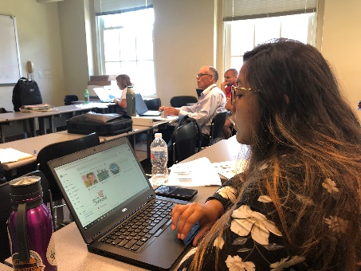
Fig. 2: Participants download materials to make their initial practice video.

One area that we focused on was making sure that the audio and voiceover was relevant to the visuals on the slide. He placed an emphasis on using audio to add to what viewers see on the slide, using the phrase “say what you see, see what you say”, which is a tool to make sure that your audio aligns with the visuals on the slide and the animation of different visuals on the slide. Some of the tools used for this component was how to insert video files to enhance the full presentation and how to find media from different sources that can add to the effectiveness of communication.

In the next component of the presentation, we learned how to apply these tools for the creation of our summer video. We learned how to create and save files to effectively manage our project and present it on the Wiki, and how to collect our media and store it in an efficient manner. We also learned about using a master script to create an outline of the audio and describe what each component of the video will contain. This is effective because it allows participants to meet the video requirements and efficiently communicate the necessary information in 1-3 minutes. We also identified best methods for finding visual content on the Internet and how we can find visuals that already exist on sites like YouTube. We learned how to convert YouTube videos into a video file that is insertable into our PowerPoint project. We learned that the Pinnacle video software will be useful in order to edit videos to put them into the final summer video.
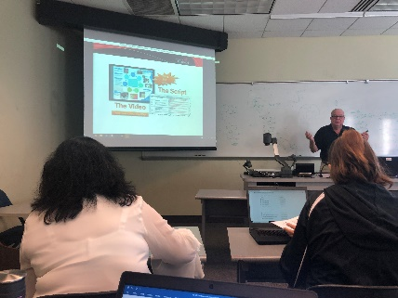

Fig. 3: Denny Dupps presents an exemplar video for participants to see a master script.

Finally, Mr. Dupps created a simple outline on how to create our summer video. The first priority is to create an outline of the project requirements and how we can obtain media that will fit into the project and meet the requirements. Next, participants will create a PowerPoint and include an overview of research and the teacher team’s individual backgrounds. An important distinction is that the final project should flow with the available audio, and if a slide has a video, a voiceover would not be necessary.

Following the overview of how to utilize PowerPoint to make a video, Mr. Dupps led us through an example of how to make a video. We created a simple practice video that utilized the format, visual, audio, and animation tools that we learned about during the presentation. This gave participants an opportunity to practice the skills that they learned and ask questions about the process.

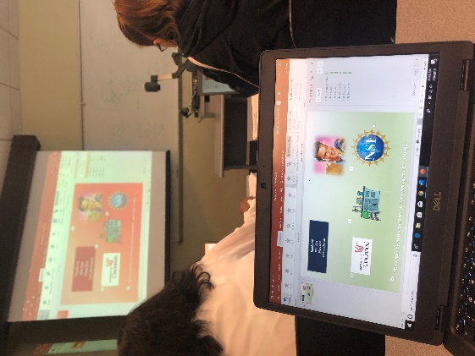

Fig. 4: An example of a participant’s practice video in comparison to Dennis Dupp’s exemplar.

This presentation was the first of two parts; in the second part of the presentation on Thursday, July 11, 2019, participants will create a video to use the tools identified and practice how to make a video that utilizes the Pinnacle software as well. Mr. Dupps will continue this presentation and integrate more tools for creating the video that captures participants’ summer research.

